K.V.R. GOVERNMENT COLLEGE FOR WOMEN (A) KURNOOL

HEHERITAGE CLUB

March-2022 Activity

The Heritage Club Organised a visit to Handicraft Exibition at BAS Function Hall in Kurnool on

04-03-2022. we are glad that 35 students got an oppotunity in visiting this exibition. They are able to

see unique art and craft from various part offf the country. It made the students understand the

cultural diversity of our Nation and they felt proud of our cultural heritage. The Objective of

visiting this exibition is to preserve and promote trational handicraft.

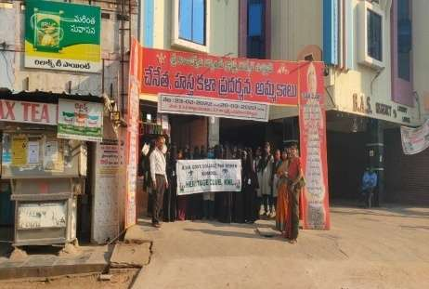 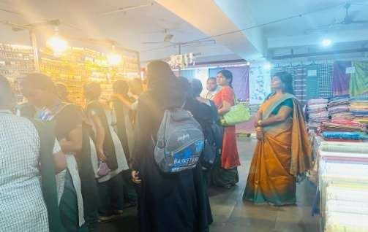

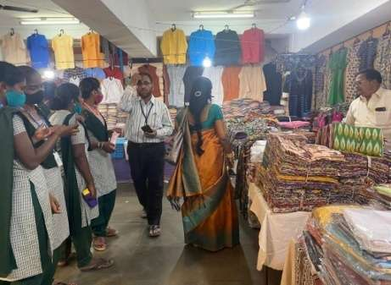 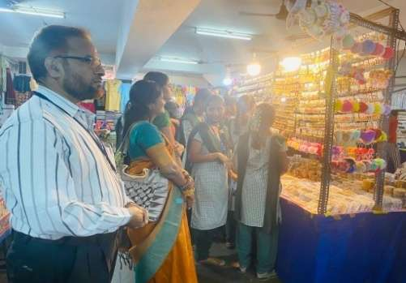

The The Department of History underUnder Heritage Club Organised one day to Lepakshi onon 25-03-2022 which is in Ananthapur District. AAttractions are biggest biggest monolithic Nandi and Sri Veerabhadra Swamy mono Temple. The Temple is having large mandap sarrounded by GodsGods/goddess carved pillars. Five facaulty acconpanied 95 students of KVR College.

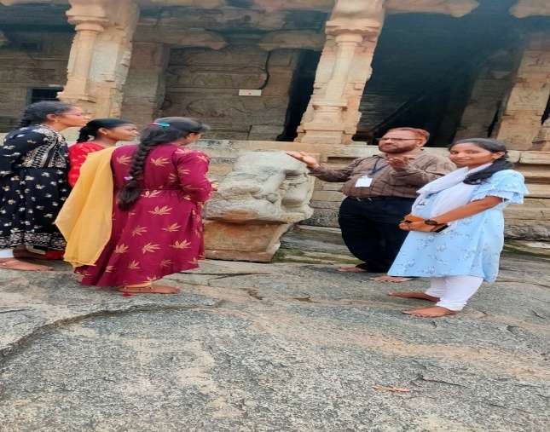 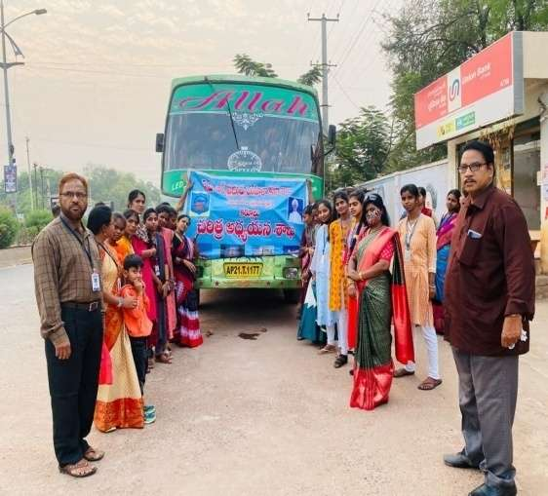

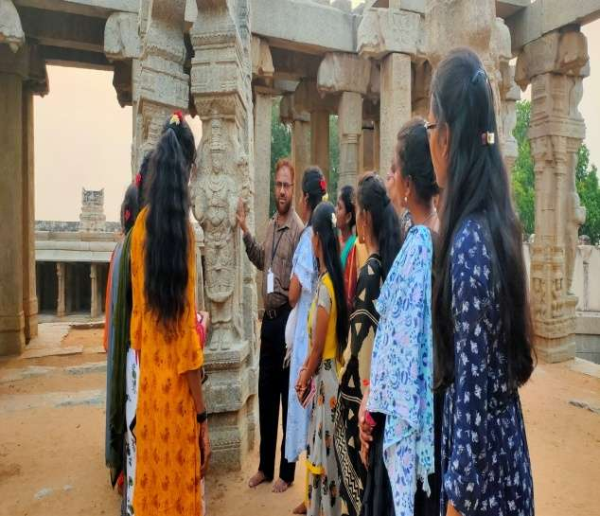 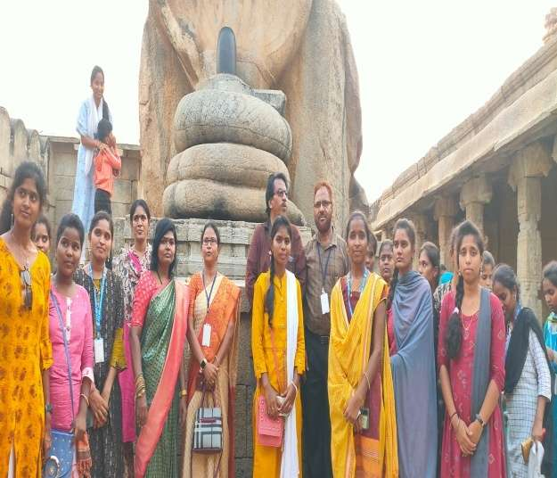

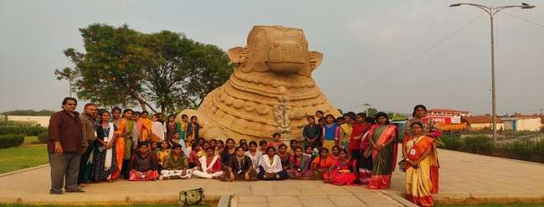

The Department of History underUnder Heritage Club vvisited the grand looking Temple of ISKCON on 25-03-2022 which is in the shape of horse drawn chariot, with statues of four huge horses at the entrance. The Temple is known as Radha Partha Saradhi Temple built bythe International Society for

Krishna consciousness. It is situated at somaladoddiVillage which is in the outscruts of Ananthapur.

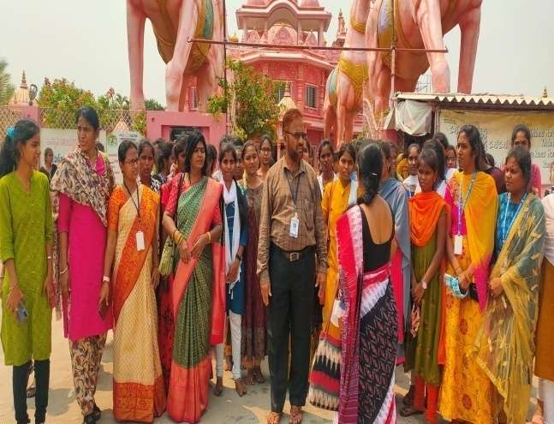

The Department of History and Urder under the Heritage Club organised one day Educational Tour to Golkonda Fort ofof Qutub Shahi kings on 26-03-2022of of which is undoubtedly one of the most magnificentent fortress complexes in India. The inner fort contains ruils of palaces, mosques and a hill top pavilion whi which gives a birds eye view of other buildings.which gives a birds

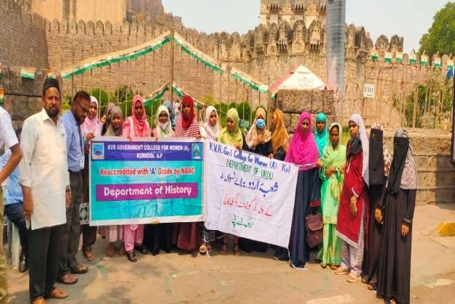 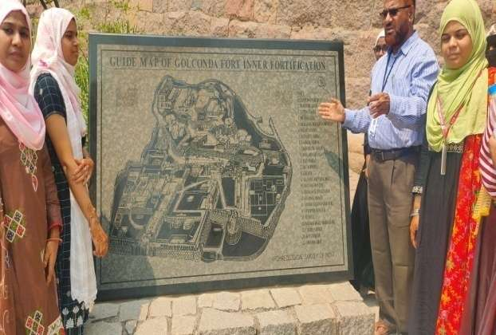

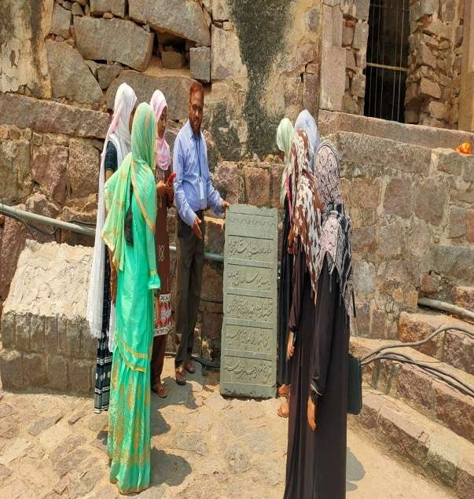 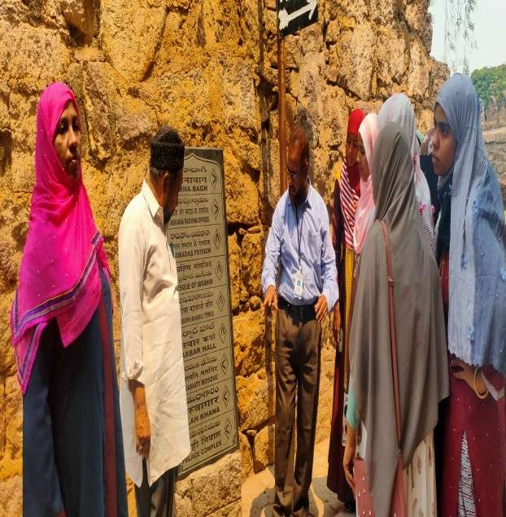

The Department of History and Urder under the Heritage Club organised one day

Educational Tour to S Saalar Jung Muuuseuuum, Hyderabad. The Muuuuuuseuum has a ffamous Quran collection from arround the World in different fonts and designs. The Museum was established in the year 1951 and is located on the soudern bank of river moosi in Hyderabad. It has rare Art Objects from all over the World. Three faculty and 35 students participated in this Tour

